


West Coast Collaborative
Specialist Mathematics Units 3 & 4
Test 1 2018
Calculator Free Section

Name: __________________________ Score: _____ / 20
Time Allowed: 20 minutes Total Marks: 20
Materials Allowed: SCSA formula booklet
Instructions: Where a question or part of a question is worth more than 2 marks sufficient working to justify your solution is required.

- [7, 1, 2, 1 marks]
One of the three cube roots of a complex number Z is $z_{1}$, where $z_{1}=2\left(i-\sqrt{3}\right)$.
- On the Argand plane, accurately sketch the 3 cube roots of Z.

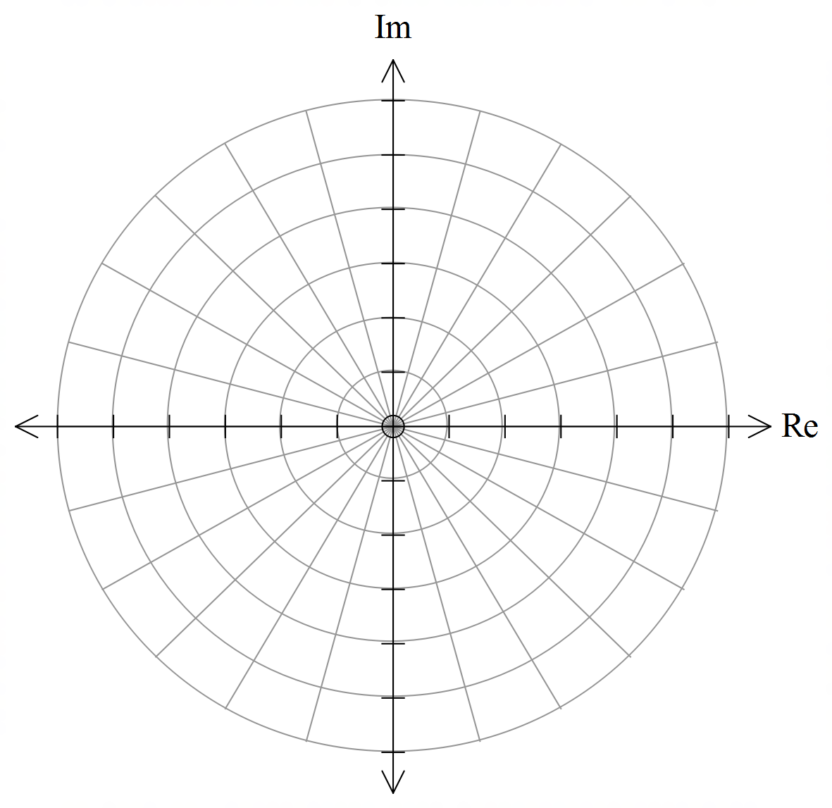
- Determine as exact values:
  - $z_{1}+z_{2}+z_{3}$

  - $z_{1}×z_{2}×z_{3}$ in polar form

  - Z in polar form

- [4 marks]
The diagram below shows the unit circle in the complex plane and the position of three complex numbers
w, u and v.
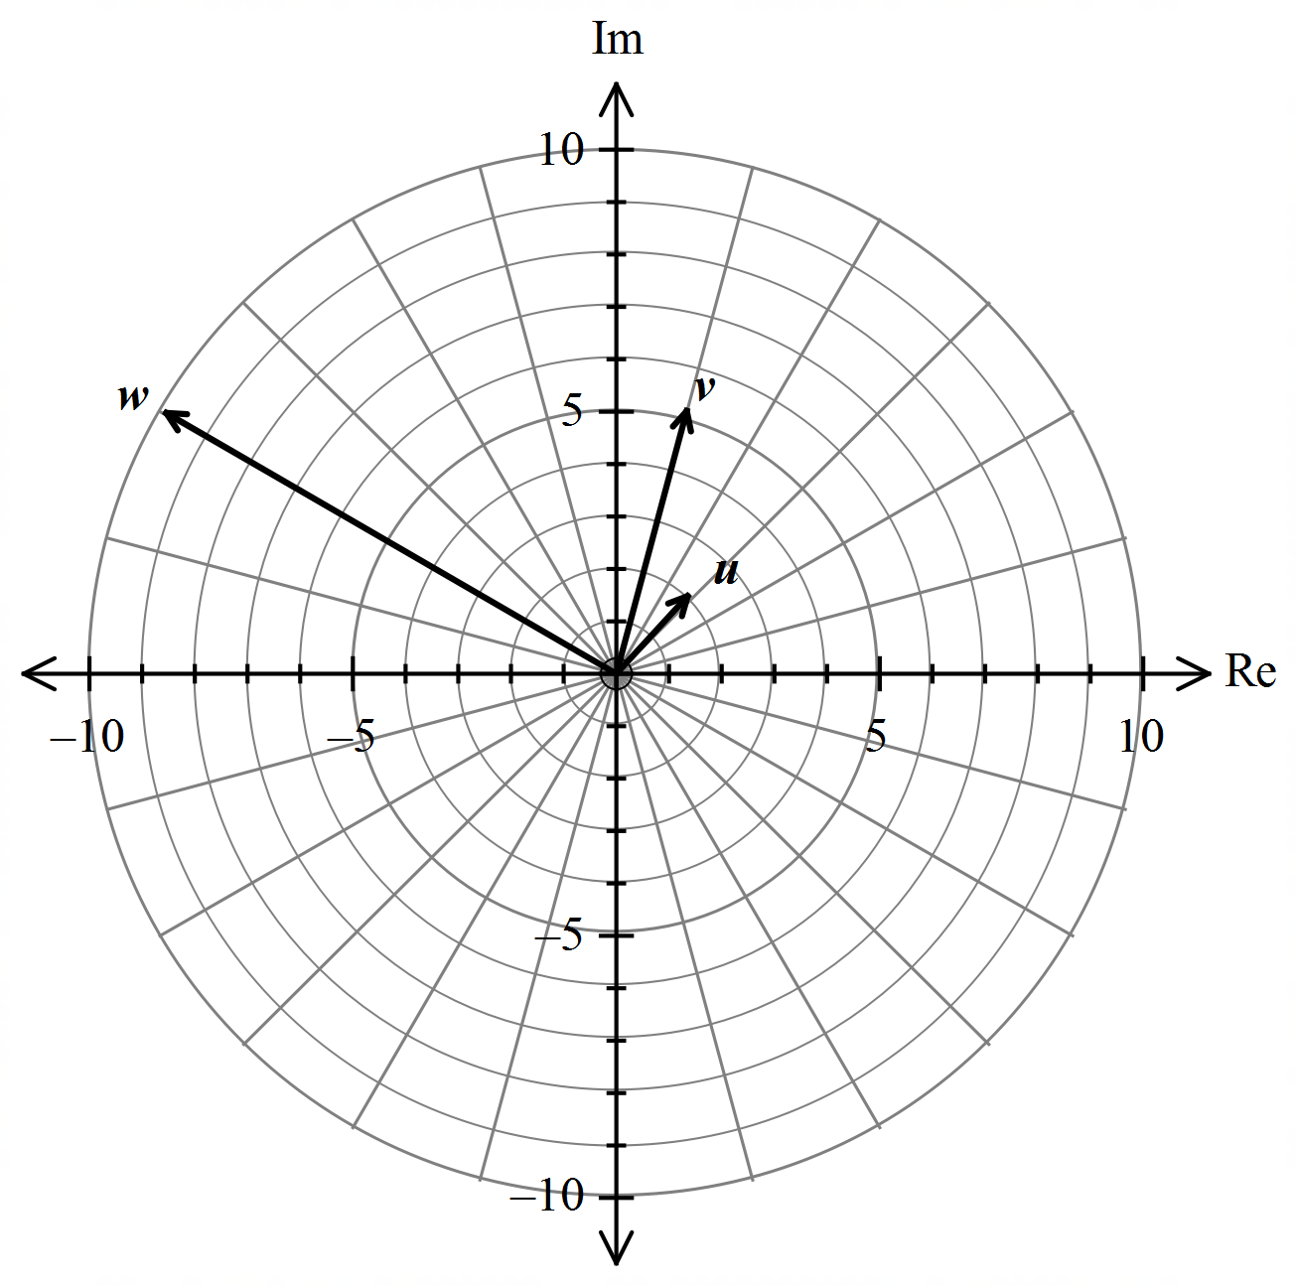

On the diagram above plot the following:

a. $z_{1}=uv$

b. $z_{2}=\frac{1}{w}$

c. $z_{3}=i\overline{v}$

d. $z_{4}=v-2u$

- [5 marks]
The polynomial $P\left(z\right)=3z^{4}-3z^{3}+az^{2}+bz-3$ has a factor of $z+1$ and leaves a remainder of 51 when $P(z)$ is divided by $z-2$. Determine the values of a and b.




West Coast Collaborative
Specialist Mathematics Units 3 & 4
Test 1 2018
Calculator Assumed Section

Name: _______________________ Score: _____ / 36
Time Allowed: 35 minutes Total Marks: 36
Materials Allowed: SCSA formula booklet, SCSA approved calculators and one A4 page of notes (both sides).
Instructions: Where a question or part of a question is worth more than 2 marks sufficient working to justify your solution is required.

- [6 marks]
Solve the equation $z^{3}+z^{2}-z+15=0$.

- [3, 3 marks]
a. Given $z=rcisθ$, prove that $\overline{z}+\frac{1}{z}=\frac{\left(r^{2}+1\right)}{r}\overline{z}$

b. Hence, show that ${\left(\sqrt{3}+i+\frac{1}{\sqrt{3}-i}\right)}^{n}= {\left(\frac{5}{2}\right)}^{n}cis\frac{nπ}{6}$

- [4, 4 marks]
Two complex numbers are given by $u=3i$ and $v=\frac{-3\sqrt{2}-3\sqrt{2}i}{2}$
a. Express $u^{3}v$ in the form $rcisθ$ , where $-π<θ≤π$ and $r≥0$.

b. Use de Moivre’s theorem to determine all the solutions for $z$ in polar form, given $z^{4}=u^{3}v$ .

- [5, 2 marks]
a. Sketch in the complex plane the region satisfying the two inequalities given by
$$\left|z-\sqrt{3}-i\right|≤2 ∩ \left|z\right|≥\left|z-\sqrt{3}-3i\right|$$
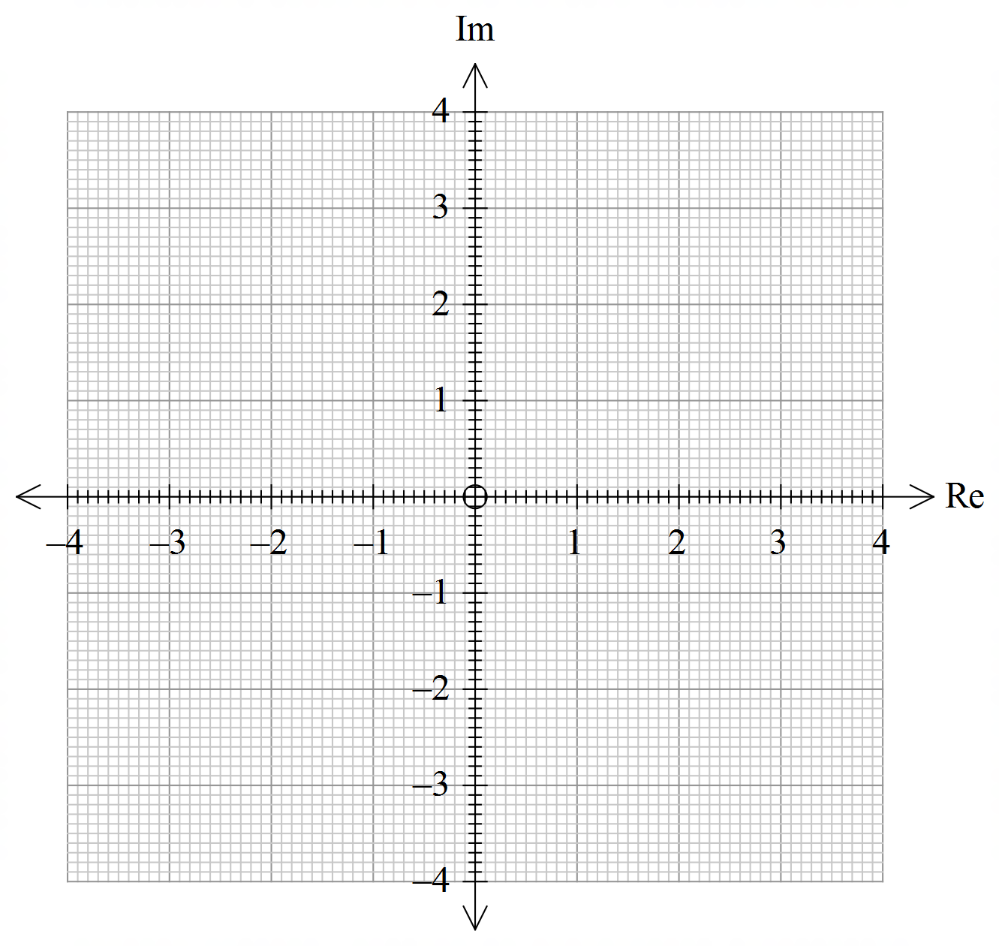

b. If z is the complex number that satisfies both inequalities in part a, determine the minimum and maximum values of $\left|z\right|$.

- [3 marks]
Use de Moivre’s theorem to prove $\cos\left(3θ\right)=\cos^{3}θ-3cosθ\sin^{2}θ$

- [6 marks]
Determine the centre and radius of the circle described by z, where $arg\left(\frac{z-1}{z+1}\right)=\frac{π}{4}$.
Hint: Investigate the Cartesian equation by letting $z=x+yi$.

